Date / Time
Customer nr.
Your nr.
25/03/2022 / 09:21
HU - 3
66915 /
Order nr.
7234493
Last research date 25/03/2022
Crefoport Hungary
Page
1 from 7
Company identiﬁcation
´
´
´
´
´
´
BRAVO-MODELL KERESKEDELMI ES SZOLGALTATO BETETI TARSASAG
Ka´ra´sz u. 6.
6720 Szeged
Hungary
Crefo Nr.
Statistical Nr.
Tax Nr.
9310840456
21766303477211706
21766303206
Registration:
Registration Nr.
Status
Csongra´d megye
0606009956
active
+36(62)426865
bravocipo@gmail.com
Solvency index
286
Solvency index between 261 and 310 means ”medium rating”.
Probability of default within 1 year in this class is: 1,5 – 3,0
This class represents medium risk in a business partnership.
Solvency index is a very strong and capable early-alarm indicator enabling a fast assessment of solvency of business
partners. The higher the solvency index, the higher the risk of default of a client. The solvency index ranges from 100, a very
good rating, to 600 where highly negative characteristics are present.
Economic situation
Business connection
Terms of payment
Credit Limit
the establishing of the business connection may be allowed
without compliants, supplier feedback show no negative data
495 000
1 319
(31)
(39)
HUF
EUR
Basic information
Credit reports provided by Crefoport are intended solely for the recipient. Content of the credit report is determined in accordance to the data protection law of the respective country.
When purchasing a credit report the recipient agrees to the following conditions. Crefoport accepts no liability - excluding deliberate acts - in respect to the contents of the credit report
being correct or that the recipient can use it for the intended purposes. The same applies to legal representatives or agents of Crefoport. The recipient may only process or use the
provided data for the purpose of which they have been transmitted; disclosure to third parties is not permitted.
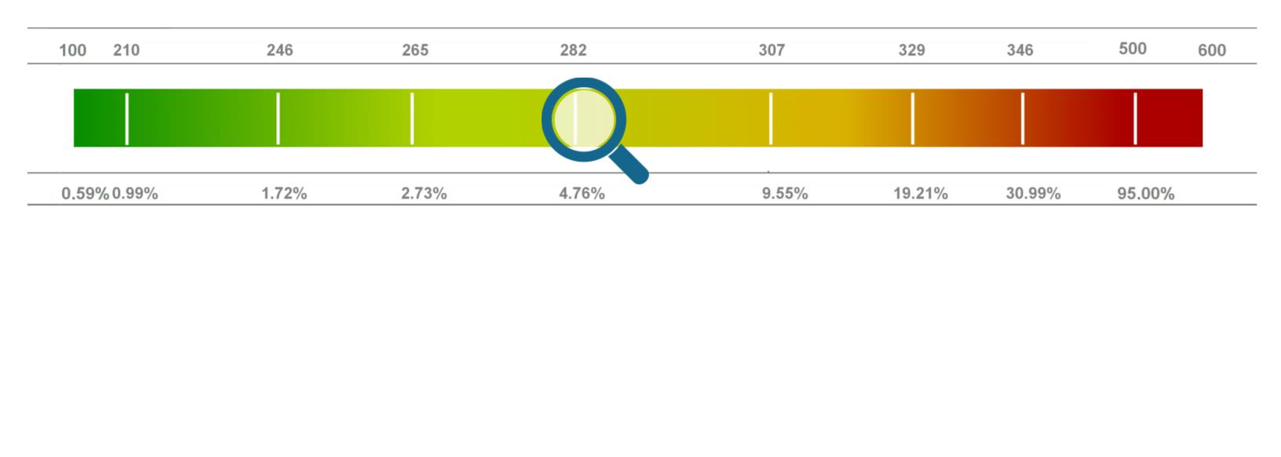

Date / Time
Customer nr.
Your nr.
25/03/2022 / 09:21
HU - 3
66915 /
Order nr.
7234493
Last research date 25/03/2022
Crefoport Hungary
Page
2 from 7
Legal form
Limited partnership
Founded
01/04/1998 as Limited partnership
Registration
03/06/1998, Csongra´d megye, 0606009956
Statistical Nr.: 21766303477211706
Tax Nr.: 21766303206
Registered names
Valid from
03/06/1998
Valid from
Short name
BRAVO-MODELL Bt.
Full name
Valid until
Valid until
BRAVO-MODELL Kereskedelmi e´s Szolga´ ltato´ Bete´ti Ta´rsasa´g
Owners and Capital
Crefo Nr.
Name / Address / Status
From
Share
Limited partner
9320809202
Da´vid Horva´th (birth date 29/05/1980)
6723 Szeged, Sa´ndor utca 33. A. e´p. Hungary
23/09/2019
General partner
9320809201
Ilona Rozgonyi (birth date 28/08/1956)
6723 Szeged, Sa´ndor utca 33. A. e´p. Hungary
23/09/2019
Registered capital
Date
Currency
Value
01/04/1998
HUF
70 000
Management
Crefo Nr.
Name / Address / Status
Since
Power of attorney
Representative
9324894823
Ilona Rozgonyi (birth date 28/08/1956)
manager
6725 Szeged, Va´radi utca 24. 1. Hungary
23/09/2019
authorized to sign alone
Credit reports provided by Crefoport are intended solely for the recipient. Content of the credit report is determined in accordance to the data protection law of the respective country.
When purchasing a credit report the recipient agrees to the following conditions. Crefoport accepts no liability - excluding deliberate acts - in respect to the contents of the credit report
being correct or that the recipient can use it for the intended purposes. The same applies to legal representatives or agents of Crefoport. The recipient may only process or use the
provided data for the purpose of which they have been transmitted; disclosure to third parties is not permitted.
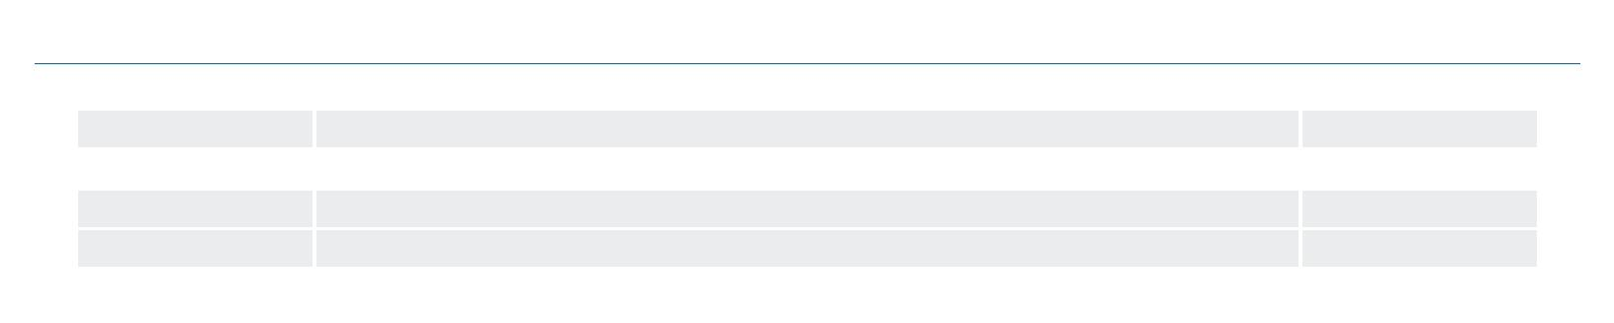
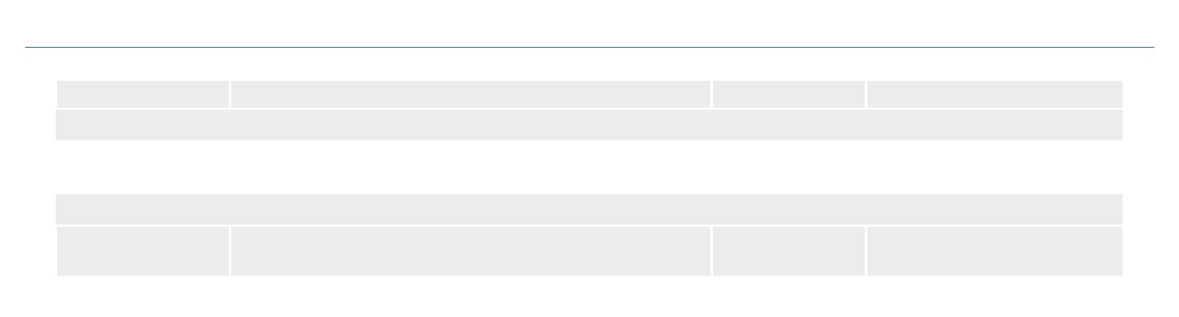
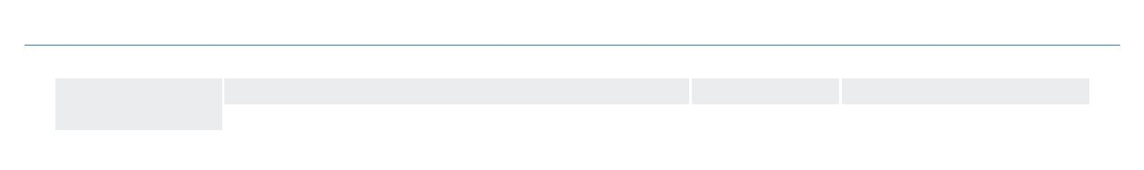
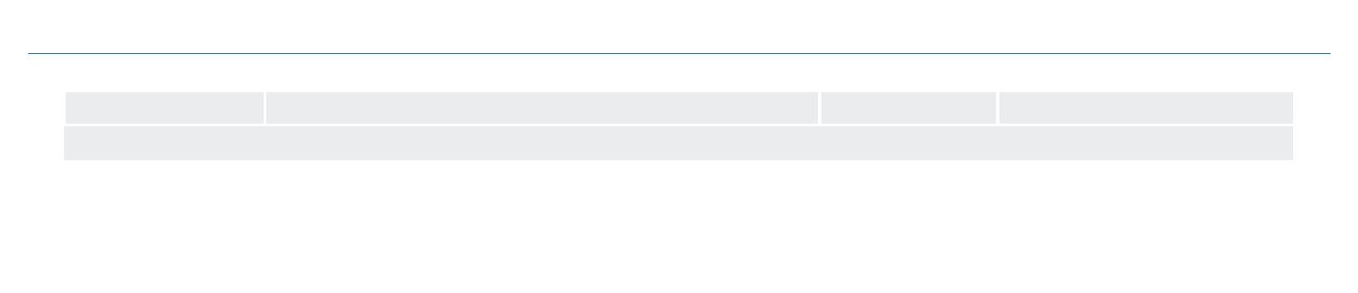

Date / Time
Customer nr.
Your nr.
25/03/2022 / 09:21
HU - 3
66915 /
Order nr.
7234493
Last research date 25/03/2022
Crefoport Hungary
Page
3 from 7
Company addresses
Valid from
01/04/1998
Residence address
6720 Szeged, Ka´ra´sz u. 6., Hungary
Valid until
Business activities
Main activity
Insolvency
De´l-alfo¨ ldi
re´ gio´
7,14 %
Csongra´d
8,00 %
Nace
risk
Retail sale of footwear and leather goods in spe-
cialised stores
5,95 %
4772.
Additional activities
Insolvency
risk
De´l-alfo¨ ldi
re´ gio´
Csongra´d
Nace
Retail sale of textiles in specialised stores
Retail sale of clothing in specialised stores
Retail sale via mail order houses or via Internet
Renting and operating of own or leased real estate
Repair of footwear and leather goods
5,47 %
6,56 %
2,18 %
2,03 %
5,17 %
7,35 %
7,64 %
1,57 %
2,89 %
0,00 %
10,00 %
10,73 %
1,23 %
3,70 %
0,00 %
4751.
4771.
4791.
6820.
9523.
Economic data
Turnover and Employees
Date
2007
2008
2009
2010
2011
2012
2013
2014
2015
2015
2016
2016
2017
2017
2018
2018
2019
2019
Turnover
Employees
3
4
2
2
2
2
2
2
2
63 986 000 HUF
57 729 000 HUF
41 657 000 HUF
44 430 000 HUF
38 855 000 HUF
49 561 000 HUF
57 397 000 HUF
55 781 000 HUF
59 390 000 HUF
62 588 000 HUF
57 019 000 HUF
54 092 000 HUF
2
2
2
2
Credit reports provided by Crefoport are intended solely for the recipient. Content of the credit report is determined in accordance to the data protection law of the respective country.
When purchasing a credit report the recipient agrees to the following conditions. Crefoport accepts no liability - excluding deliberate acts - in respect to the contents of the credit report
being correct or that the recipient can use it for the intended purposes. The same applies to legal representatives or agents of Crefoport. The recipient may only process or use the
provided data for the purpose of which they have been transmitted; disclosure to third parties is not permitted.
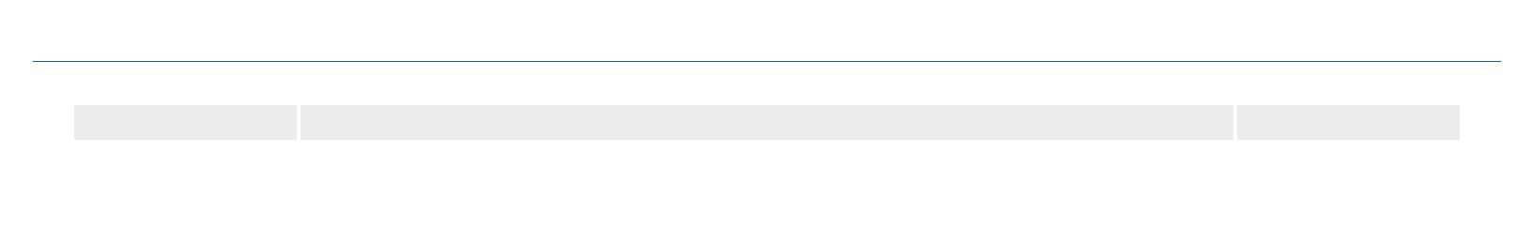
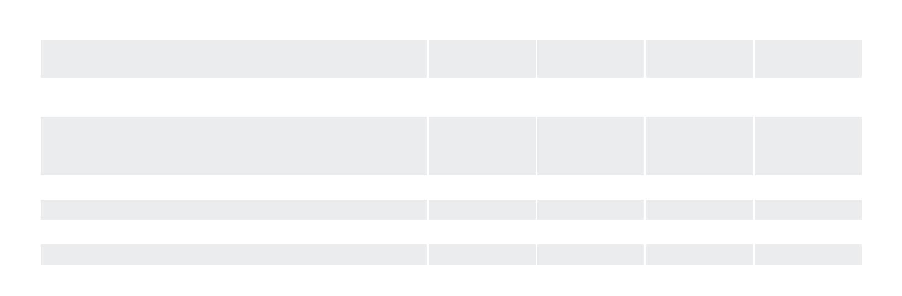
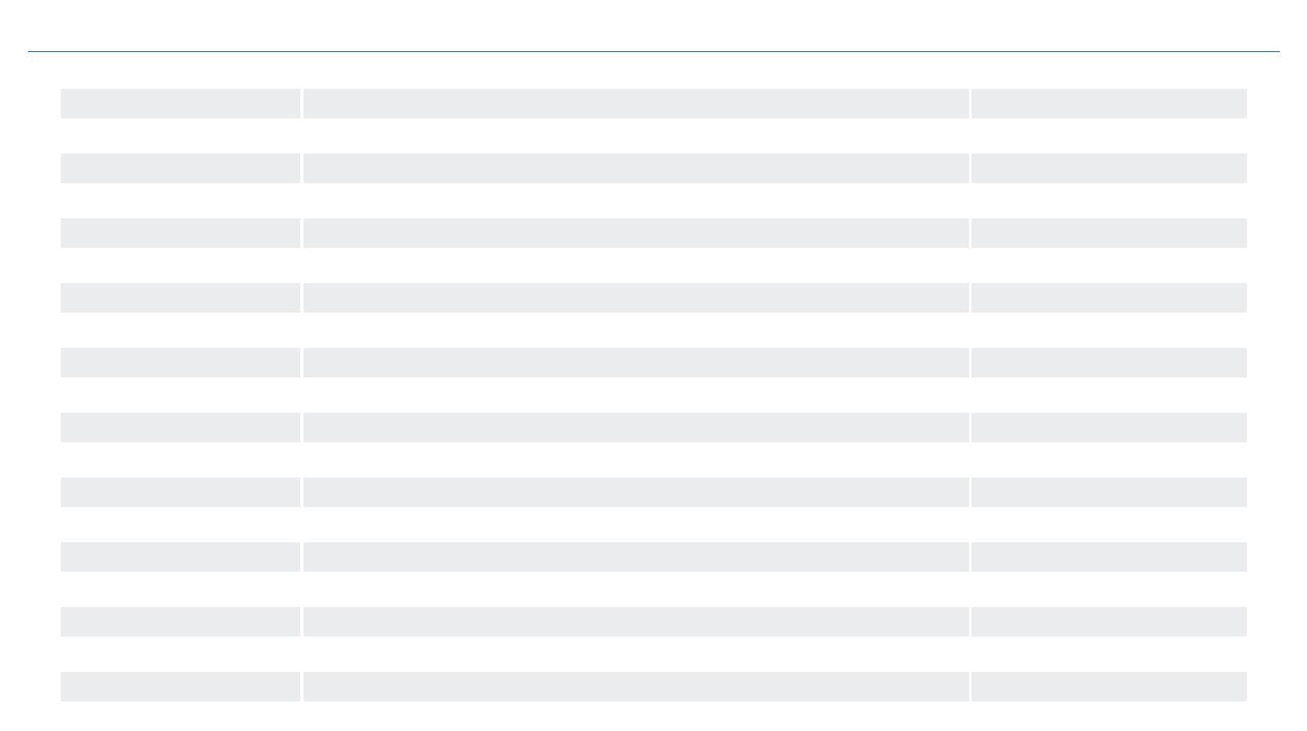

Date / Time
Customer nr.
Your nr.
25/03/2022 / 09:21
HU - 3
66915 /
Order nr.
7234493
Last research date 25/03/2022
Crefoport Hungary
Page
4 from 7
2020
2
2020
37 935 000 HUF
2021
1
1
1
1
05/01/2022
02/02/2022
03/03/2022
Supplementary data
Banks
Code
10300002
Bank name / Address
Va´ci utca 38. , Budapest 1056,
Va´ci utca 38. , Budapest 1056,
Account Nr.
10300002-10137150-48820019
10300002-10137150-49020016
MKB Bank Nyrt.
MKB Bank Nyrt.
10300002
Main indices
Payment experience and credit opinion
Terms of payment
Business connection
Credit Limit
without compliants, supplier feedback show no negative data
the establishing of the business connection may be allowed
495 000
1 319
(39)
(31)
HUF
EUR
Business development
Company development
Business course
Company development stagnative
satisfactory
(39)
(31)
Events
Date
Kind
Code
Taxpayer without public debts
20/03/2017
1010
Debt total: 0
Taxpayer without public debts
25/07/2017
05/05/2021
1010
1008
Debt total: 0
A reliable taxpayer
Debt total: 0
Balances
Balance
Credit reports provided by Crefoport are intended solely for the recipient. Content of the credit report is determined in accordance to the data protection law of the respective country.
When purchasing a credit report the recipient agrees to the following conditions. Crefoport accepts no liability - excluding deliberate acts - in respect to the contents of the credit report
being correct or that the recipient can use it for the intended purposes. The same applies to legal representatives or agents of Crefoport. The recipient may only process or use the
provided data for the purpose of which they have been transmitted; disclosure to third parties is not permitted.
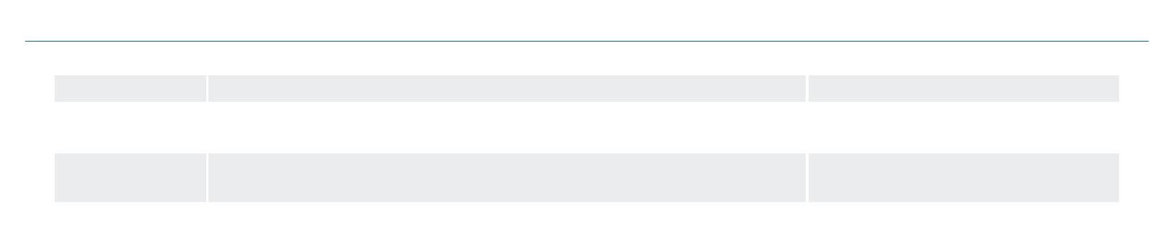
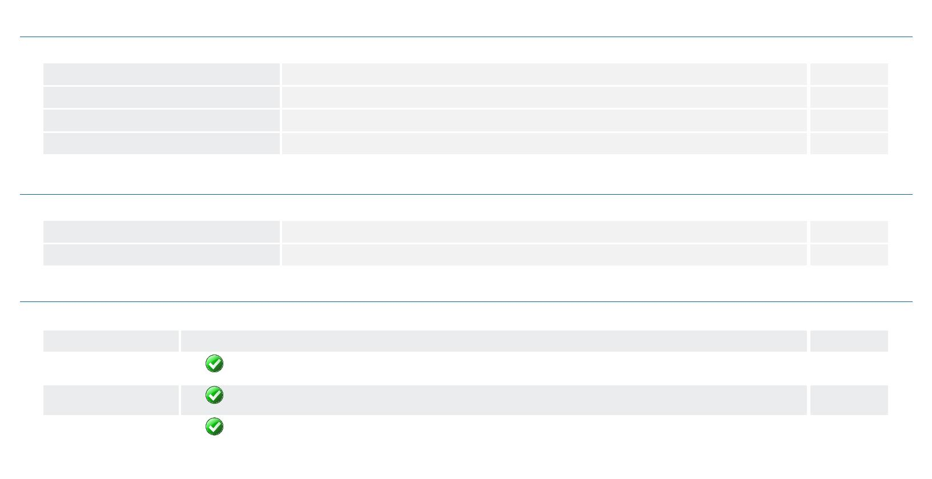

Date / Time
Customer nr.
Your nr.
25/03/2022 / 09:21
HU - 3
66915 /
Order nr.
7234493
Last research date 25/03/2022
Crefoport Hungary
Page
5 from 7
2020.12.31. The enclosed balance of 2020 is originated from ofﬁcial source, it is authenticated by the auditor .
2019.12.31. The enclosed balance of 2019 is originated from ofﬁcial source, it is authenticated by the auditor .
2018.12.31. The enclosed balance of 2018 is originated from ofﬁcial source, it is authenticated by the auditor .
2017.12.31. The enclosed balance of 2017 is originated from ofﬁcial source, it is authenticated by the auditor .
31/12/2020
1000
31/12/2019
1000
31/12/2018
1000
31/12/2017
1000
Name
HUF
HUF
HUF
HUF
balance
balance
balance
balance
FIXED ASSETS
153
188
244
386
Intangible assets
Tangible assets
0
153
0
0
188
22
222
130
256
Financial investments
CURRENT ASSETS
Inventories
0
0
0
36 847
36 146
200
0
36 035
35 114
324
38 058
36 130
888
44 199
42 302
1 387
0
Receivables
Securities
0
0
Liquid assets
501
0
597
1 040
0
510
PREPAID EXPENSES AND ACCRUED INCOME
TOTAL ASSETS
0
0
37 000
25 478
70
36 223
25 428
70
38 302
25 332
70
44 585
24 386
70
SHAREHOLDERS’ EQUITY
Capital subscribed
thereof: treasure shares repurchased at face
value
0
Issued but not paid capital (-)
Capital reserves
0
0
0
0
0
25 358
0
0
25 262
0
0
24 316
0
0
23 849
0
Retained earnings from previous years
Non-distributable reserves
Revaluation reserve
After tax proﬁt
50
96
946
467
0
PROVISIONS
0
0
0
LIABILITIES
11 522
10 795
12 970
20 199
0
Subordinated liabilities
Long term liabilities
Short term liabilities
0
0
0
0
11 522
0
0
10 795
0
0
12 970
0
3 350
16 849
0
ACCRUED EXPENSES AND DEFERRED IN-
COME
TOTAL LIABILITIES AND SHEREHOLDERS
EQUITY
37 000
36 223
38 302
44 585
Proﬁt and loss accounts
2020.12.31. The enclosed proﬁt and loss account of 2020 is originated from ofﬁcial source, it is authenticated by the auditor .
2019.12.31. The enclosed proﬁt and loss account of 2019 is originated from ofﬁcial source, it is authenticated by the auditor .
2018.12.31. The enclosed proﬁt and loss account of 2018 is originated from ofﬁcial source, it is authenticated by the auditor .
2017.12.31. The enclosed proﬁt and loss account of 2017 is originated from ofﬁcial source, it is authenticated by the auditor .
Credit reports provided by Crefoport are intended solely for the recipient. Content of the credit report is determined in accordance to the data protection law of the respective country.
When purchasing a credit report the recipient agrees to the following conditions. Crefoport accepts no liability - excluding deliberate acts - in respect to the contents of the credit report
being correct or that the recipient can use it for the intended purposes. The same applies to legal representatives or agents of Crefoport. The recipient may only process or use the
provided data for the purpose of which they have been transmitted; disclosure to third parties is not permitted.
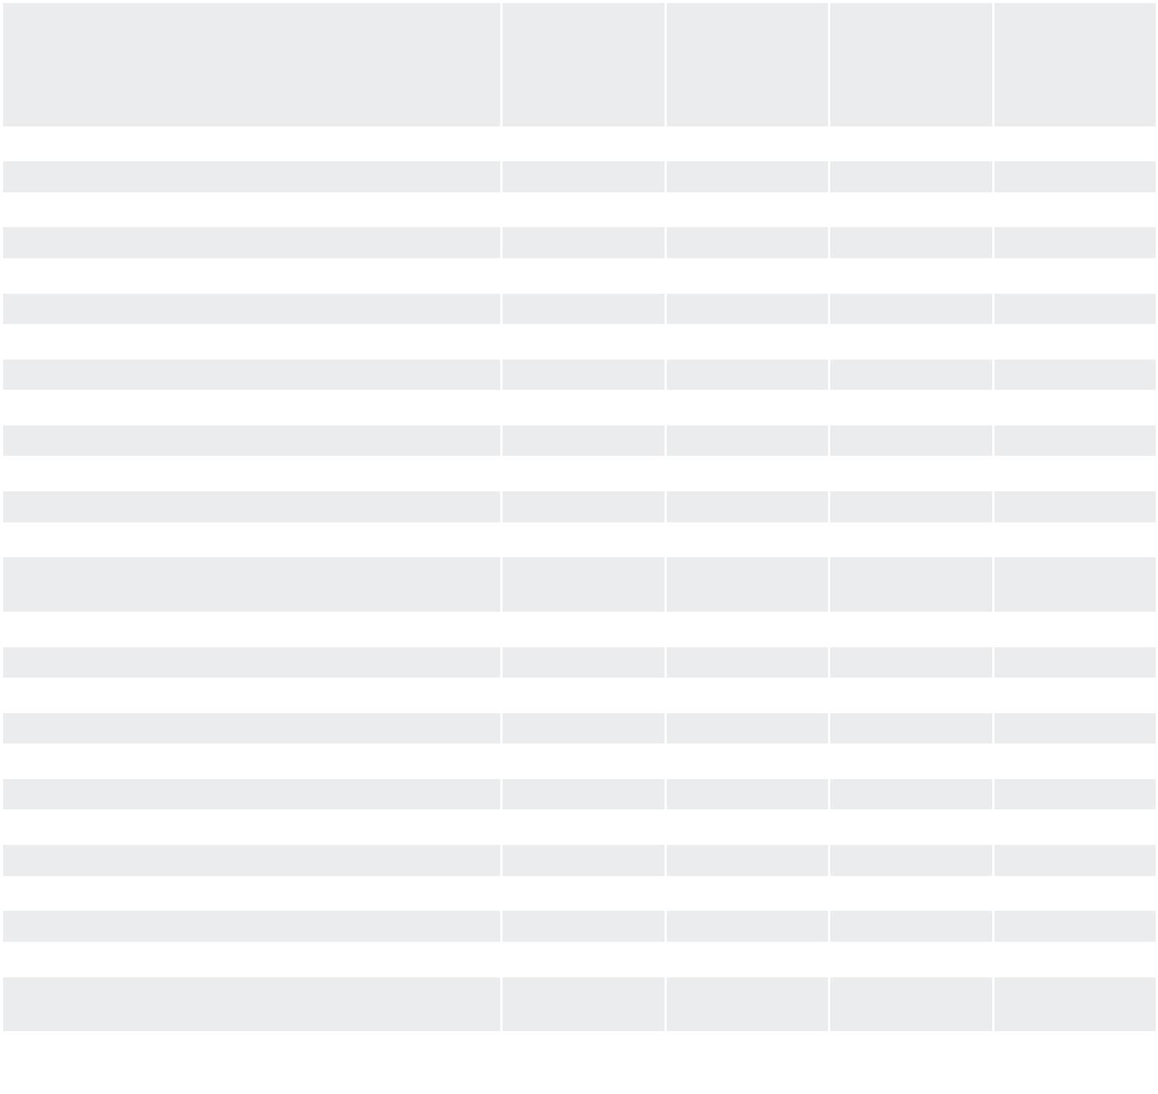

Date / Time
Customer nr.
Your nr.
25/03/2022 / 09:21
HU - 3
66915 /
Order nr.
7234493
Last research date 25/03/2022
Crefoport Hungary
Page
6 from 7
31/12/2020
1000
31/12/2019
1000
31/12/2018
1000
31/12/2017
1000
Name
HUF
HUF
HUF
HUF
proﬁt and
loss account
proﬁt and
loss account
proﬁt and
loss account
proﬁt and
loss account
Net sales revenues
37 935
0
54 092
0
57 019
0
62 588
0
Capitalised value of own performance
Other revenues
1
0
24
168
Material type expenditure
Payments to personnel
Deprecation change
35 992
1 397
34
49 720
3 307
57
51 825
3 076
142
58 170
3 349
175
Other expenses
157
356
661
828
-167
189
139
50
71
121
205
TRADING PROFIT
937
126
663
-537
400
304
96
1 879
83
857
Revenues from ﬁnancial transactions
Expenditures of ﬁnancial transactions
FINANCIAL PROFIT
258
654
530
-571
1 308
362
-272
585
NET PROFIT BEFORE TAXATION
Tax liability
118
AFTER TAX PROFIT
946
467
Financial Ratios
Name
31/12/2020
0,69
31/12/2019
0,70
31/12/2018
0,66
31/12/2017
0,55
Equity ratio
Cleared equity ratio
Current liquidity
0,69
0,70
0,66
0,55
3,20
3,34
2,93
2,62
Quick liquidity
0,06
0,09
0,15
0,11
Working capital
25325000,00
0,31
25240000,00
0,30
25088000,00
0,34
27350000,00
0,45
Gearing
Cleared gearing
Proﬁtability
0,50
0,94
0,74
1,73
2,29
3,30
0,93
1,37
Operating proﬁtability
Stock days
347,79
1,92
236,94
2,19
231,28
5,68
246,70
8,09
Debtor days
Supplier days
116,85
68,86
0,00
79,25
70,20
0,00
91,35
66,14
0,00
105,72
54,70
12,08
13,74
7185,49
8,09
equity ratio (%)
Long term debt ratio (%)
Leverage (%)
Coverage of ﬁxed assets (%)
Receivables turnover ratio (day)
P/L after tax/Turnover (%)
Return On Investment
Interest cover
16652,29
1,92
13525,53
2,19
10381,97
5,68
0,94
1,73
3,30
1,37
0,01
0,03
0,05
0,02
0,43
1,41
2,87
1,62
Return On Equity (%)
Return On Assets (%)
Net income/Turnover (%)
Change in Turnover (%)
0,20
0,38
3,73
1,92
0,14
0,26
2,47
1,05
-29,87
-5,13
-8,90
5,38
Credit reports provided by Crefoport are intended solely for the recipient. Content of the credit report is determined in accordance to the data protection law of the respective country.
When purchasing a credit report the recipient agrees to the following conditions. Crefoport accepts no liability - excluding deliberate acts - in respect to the contents of the credit report
being correct or that the recipient can use it for the intended purposes. The same applies to legal representatives or agents of Crefoport. The recipient may only process or use the
provided data for the purpose of which they have been transmitted; disclosure to third parties is not permitted.
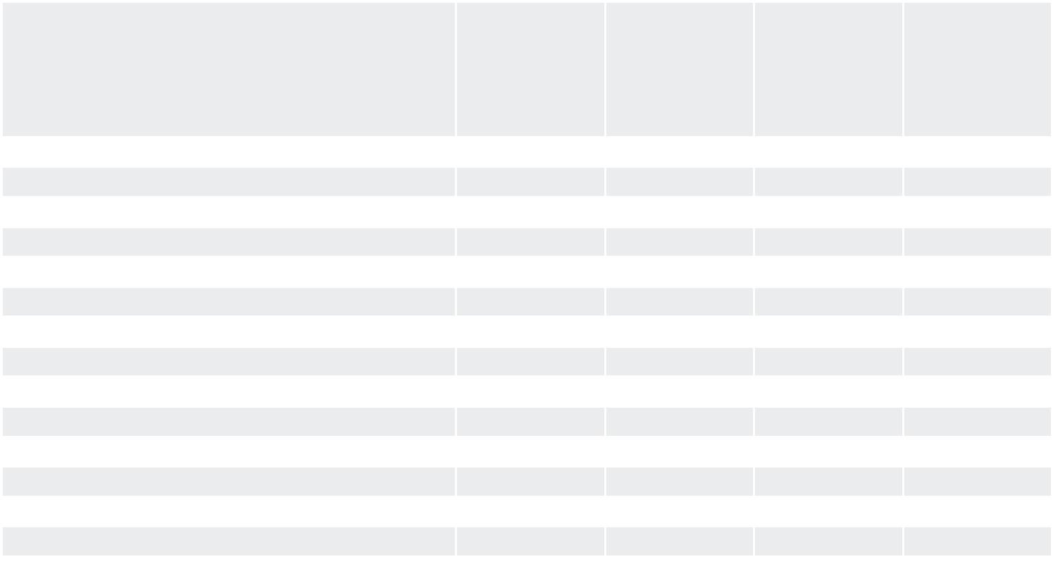
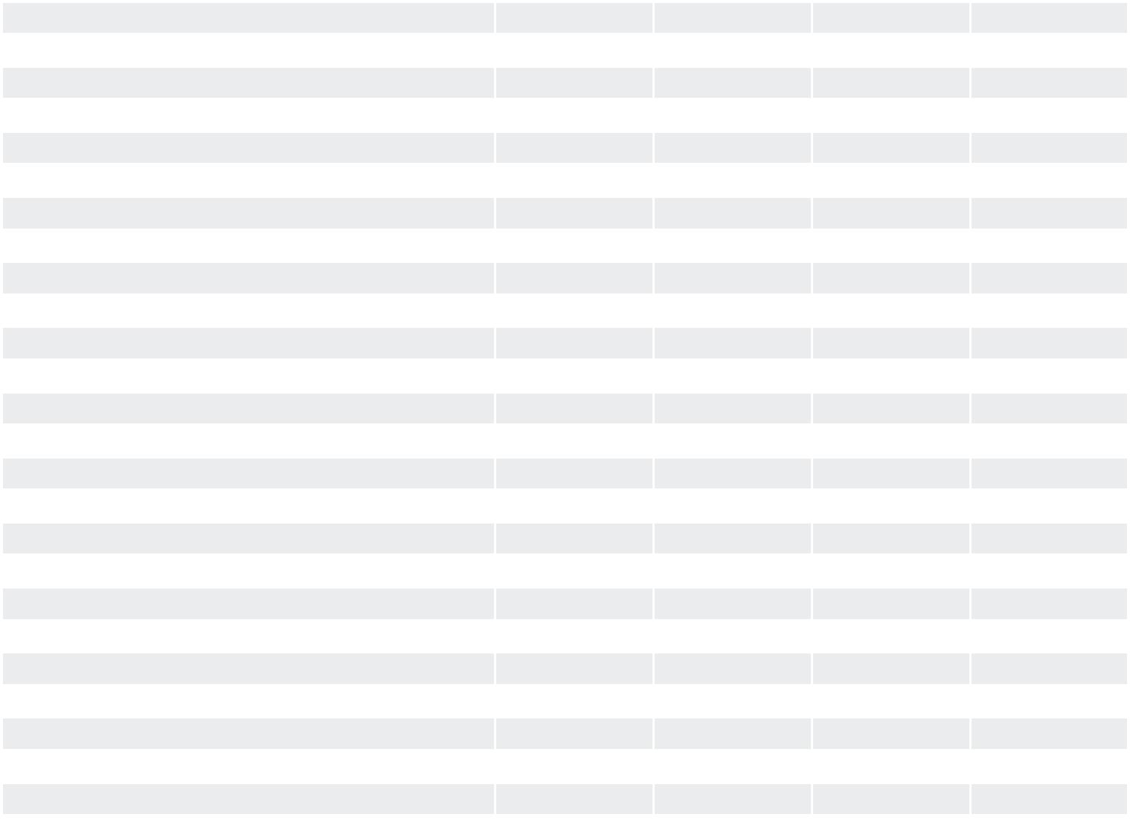

Date / Time
Customer nr.
Your nr.
25/03/2022 / 09:21
HU - 3
66915 /
Order nr.
7234493
Last research date 25/03/2022
Crefoport Hungary
Page
7 from 7
Name
31/12/2020
31/12/2019
-5,43
31/12/2018
-14,09
31/12/2017
-3,65
Change in Net income (%)
2,14
0,02
Debtors/Creditors
Change in P/L before tax (%)
Turnover
0,03
0,07
0,08
-62,01
-50,13
119,25
6,06
37935000,00
18967500,00
54092000,00
27046000,00
57019000,00
28509500,00
62588000,00
31294000,00
Turnover/Employees
Credit reports provided by Crefoport are intended solely for the recipient. Content of the credit report is determined in accordance to the data protection law of the respective country.
When purchasing a credit report the recipient agrees to the following conditions. Crefoport accepts no liability - excluding deliberate acts - in respect to the contents of the credit report
being correct or that the recipient can use it for the intended purposes. The same applies to legal representatives or agents of Crefoport. The recipient may only process or use the
provided data for the purpose of which they have been transmitted; disclosure to third parties is not permitted.
